Week 3 Task: Advanced Data Analysis and Visualization in Logistics
Delivery Route Optimization & Late Delivery Analysis

1. Project Objective
The objective of this project is to perform exploratory data analysis (EDA) on a logistics dataset and convert the results into practical operational insights. The analysis focuses on delivery performance, shipping mode, traffic conditions, distance, order value, item count, and customer region. Python, pandas, and matplotlib are used to calculate descriptive statistics, compare groups, examine relationships, and produce visualizations that can support logistics decision-making.

2. Dataset and Analytical Approach
The analysis uses the sample logistics dataset prepared for the previous preprocessing task. It contains 61 order records and 10 variables, including shipping mode, distance, scheduled delivery days, actual delivery days, order value, number of items, traffic level, customer region, and a binary late-delivery indicator. The overall late-delivery rate in the analyzed data is 47.5%.
Before EDA, missing values in distance, scheduled days, order value, and traffic level were handled using median or mode imputation. Duplicate and data-quality controls from the preprocessing workflow were retained. For predictive interpretation, actual_days is treated as a post-delivery outcome rather than a feature, because using it to predict late_delivery would introduce data leakage.

3. Exploratory Data Analysis
Central tendency and spread were reviewed for the numerical fields. The dataset contains a mix of continuous variables (distance and order value) and operational count variables (items and delivery days). Grouped aggregations were then used to compare late-delivery rates across shipping modes, traffic levels, and regions.

4. Visualization 1: Late Delivery by Shipping Mode
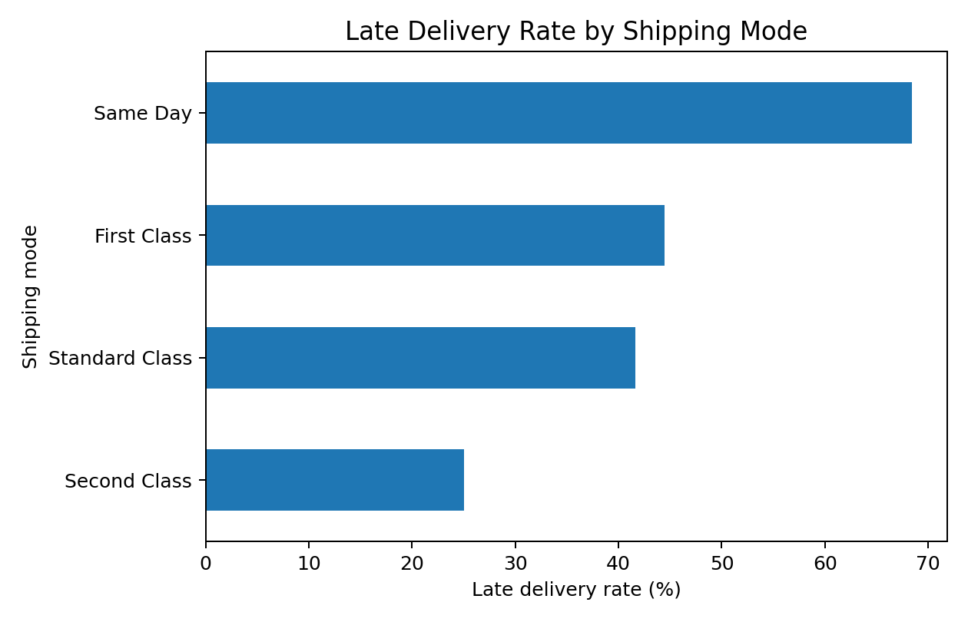
Interpretation: Same Day shipments show the highest observed late-delivery rate at 68.4%, while Second Class has the lowest at 25.0%. This suggests that shipping mode and its service-level expectations should be monitored separately rather than treating all orders as one group. A high late rate in a premium service category can be particularly important because customers may have stronger time expectations.

5. Visualization 2: Late Delivery by Traffic Level
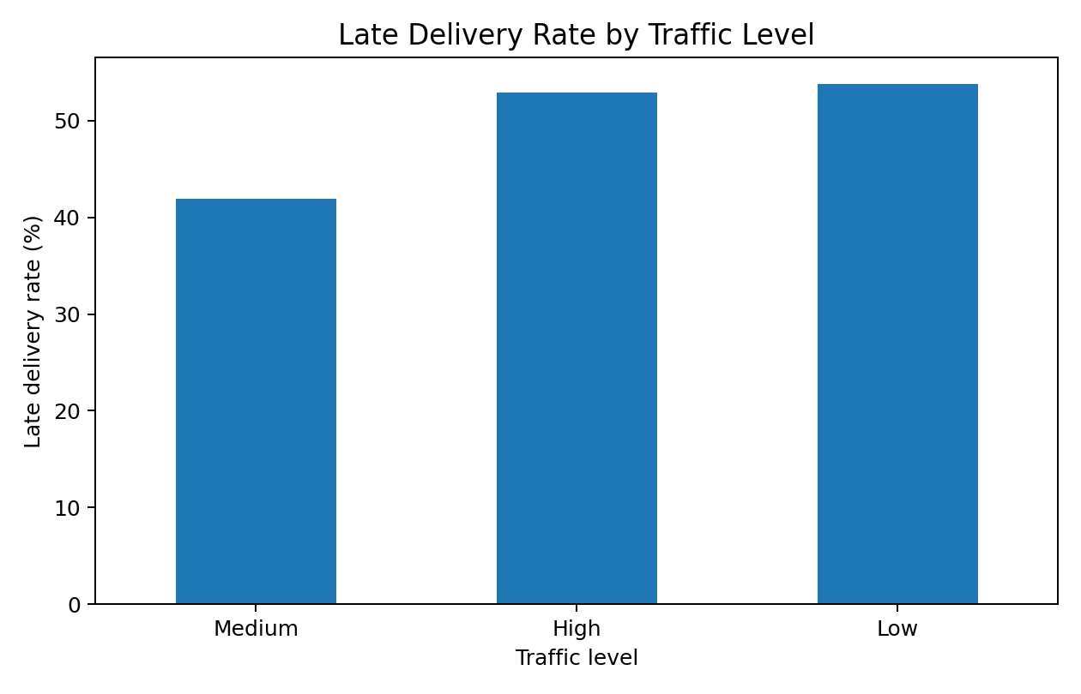
Interpretation: The grouped rates are approximately 52.9% for High traffic, 53.8% for Low traffic, and 41.9% for Medium traffic. Because the differences are not perfectly monotonic, traffic should be treated as one operational factor rather than the only explanation for late delivery. Additional variables such as route planning, dispatch timing, and service mode should be examined in a larger dataset.

6. Visualization 3: Distance vs Order Value
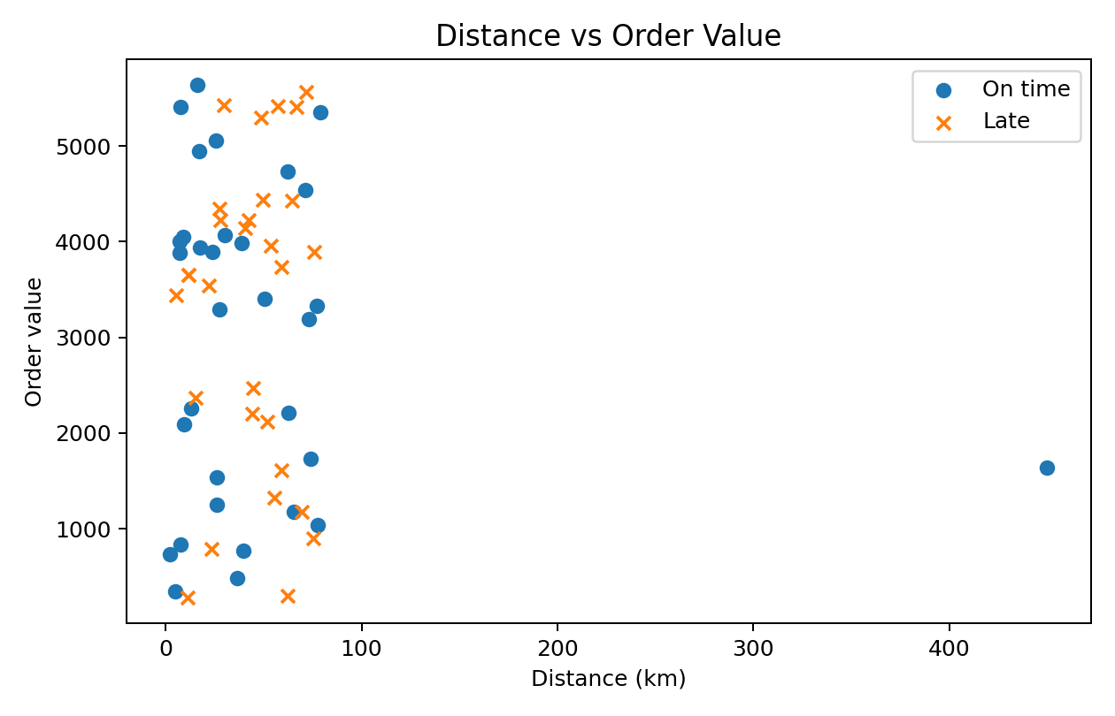
Interpretation: The scatter plot examines whether long-distance shipments are concentrated among higher-value orders. The points show considerable variation, so distance alone does not explain order value. This visualization is useful for identifying operational segments where high-value shipments also require long travel, because those shipments may deserve greater monitoring or service prioritization.

7. Visualization 4: Correlation Analysis
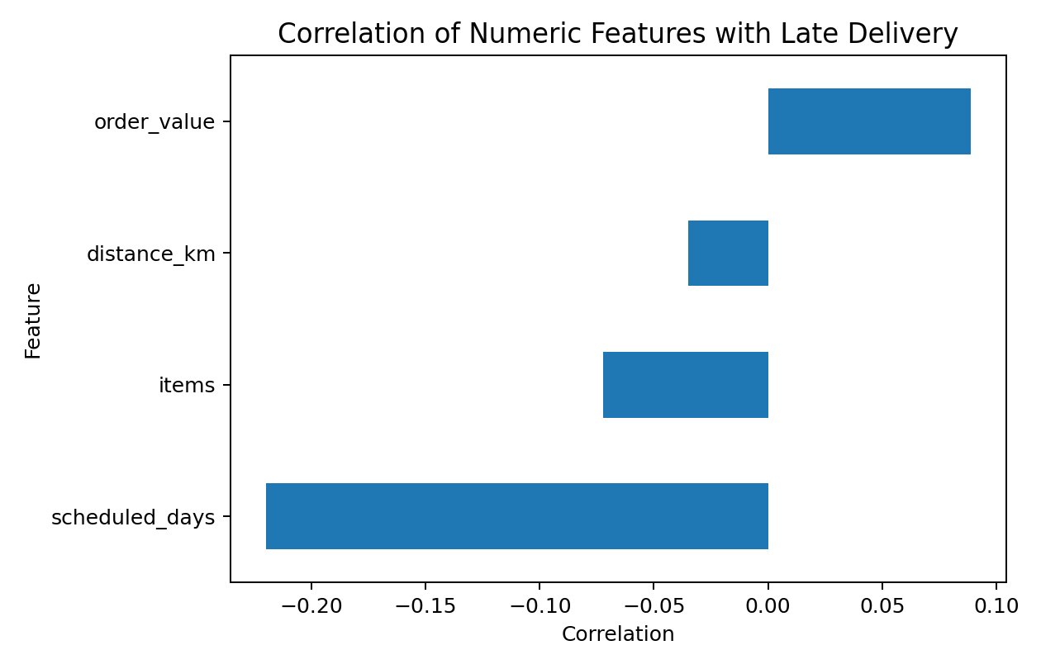
Interpretation: Correlation provides a quick numerical view of linear relationships with the late-delivery indicator. Scheduled days has a negative association in this sample, while order value has a small positive association. Distance and item count show relatively weak linear relationships. These are descriptive associations, not causal conclusions, and should be validated with more observations and suitable statistical or machine-learning models.

8. Key Findings
- The overall observed late-delivery rate is 47.5%, indicating that delivery reliability is a meaningful operational KPI.
- Late-delivery rates differ by shipping mode, with Same Day highest (68.4%) and Second Class lowest (25.0%) in this sample.
- Traffic level shows differences between groups, but the pattern is not strictly increasing from Low to High; therefore, traffic should be combined with other operational variables.
- Distance and order value show substantial variation, making segmentation useful for identifying high-value shipments that also require longer travel.
- Correlation analysis is useful for screening relationships, but correlation alone cannot establish causation.
- Actual delivery duration should not be used as a future predictive input for late-delivery risk because it is known only after delivery.

9. Business Recommendations
- Create service-mode dashboards so that delivery performance can be monitored separately for Same Day, First Class, Second Class, and Standard Class shipments.
- Use traffic information together with route, dispatch time, and distance to identify shipments that may need proactive intervention.
- Prioritize monitoring for high-value shipments and long-distance deliveries because service failures can have higher business impact.
- Track late-delivery rate, average actual-vs-scheduled days, and performance by region as recurring KPIs.
- For a production system, expand the dataset and test classification models such as logistic regression or tree-based models after proper feature engineering and train/test validation.

10. Python Tools and Methodology
The analysis script uses pandas for data loading, cleaning, grouping, descriptive statistics, and correlation calculations, and matplotlib for visualizations. The workflow is reproducible: load the CSV, handle missing values, calculate grouped KPIs, calculate correlations, and generate the charts. The accompanying GitHub project contains the script and visualization outputs.

11. Conclusion
This Week 3 analysis demonstrates how exploratory data analysis can turn logistics records into interpretable operational insights. The visualizations reveal meaningful differences across shipping modes and traffic conditions and provide a simple way to inspect relationships among distance, order value, and delivery performance. The results support a data-driven monitoring framework while also showing why a larger dataset and predictive modeling are needed before making high-stakes operational decisions.

